Information about Pali Type 1 Fonts, Character Sets and Issues

¤ ¥ à â ã ä å æ ë ì ï ð ñ ò ó ô õ ö ü ý

To use any Type 1 font on a Windows computer a version of Adobe Type Manager (ATM) must be installed. An exception to this requirement is Windows 2000 (and Windows XP – when it is available). Windows 2000 can use/display Type 1 fonts just as well as TrueType fonts.

Adobe Type Manager Lite is a free version of ATM available from Adobe, either with some of their programs or as a free http://www.adobe.com/products/atmlight/main.html (6 Mb) download from their website. A set of fully featured Pali Type 1 fonts is freely available from BuddhaNet http://www.buddhanet.net/ftp_pali.htm or from other websites. It is recommended that this family of Pali Type 1 fonts is used to minimise problems. It is a matter of first installing ATM Lite and then using ATM to install the Type 1 fonts. Or if using Windows 2000/XP just install the Pali fonts only. [Mac users can obtain ATM Lite for Mac & Mac Pali Type 1 fonts.]

A display of the Pali font families is on the next page. Each family has ten instances of the variations in the font family with the exception of Pali Chancery which has only one instance (a display font). The ten instances are not displayed but they are Regular, Bold, Italic and Bold Italic. There is also a Condensed version of the four instances with one instance each of Small Capitals and Condensed Small Capitals.

If using Word 2000 or similar it is possible to develop keyboard macros to easily input the Pali characters using the keyboard. Otherwise page 3 has a guide to manually entering the characters using the Alt + right hand keypad number set (with the NumLock light on – [otherwise this method won’t work]).

Most reliable method for inputting Pali characters (other than macros).

Please make sure the NumLock light is on, then hold down the Alt key and simultaneously enter the required keyboard combination via the right hand keypad number set (this will not work with the numbers at the top of the main keyboard). Using this method “long a” (lowercase) à is entered via the combination Alt + 224. Notice that the necessary leading zero is omitted sometimes from the number combination but this zero is needed, so the combination is really Alt + 0224. Release the Alt key after this combination is entered and the long a character à will appear. Of course you must have a Pali Type 1 font installed and be using it to enter this character, otherwise you will see à.

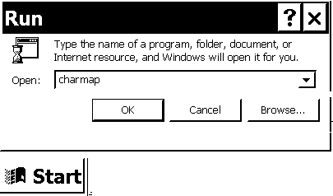
Other Desktop Publishing programs may use different methods to enter an extended character (i.e. not on the usual keyboard). The above method works in all situations. Otherwise, for example, InDesign has a “replace character” function (much like inserting via the clipboard). Running the “character map” applet can help both identify the extended character set and also insert the characters (via the clipboard). But the tiny viewing window of “charmap” makes this difficult. Print out and use the character map on page 5 for this purpose. In the Run dialog on the Start menu you can enter “charmap” or “charmap.exe” — without the quotes — to run the character map applet. There are many font viewers available – double clicking a Type 1 font when ATM is installed will allow you to view that particular font in a font window; but you will not see the extended characters in a Pali font, for example, using the ATM viewing function.
Pali Times Type 1 CSX characters
¤ ¥ à â ã ä å æ ë ì ï ð ñ ò ó ô õ ö ü ý ÿ Ñ
… ‘ ’ “ ” — • – ƒ › ‹ » « ¨ ª

Pali Helvetica Type 1 CSX characters
¤ ¥ à â ã ä å æ ë ì ï ð ñ ò ó ô õ ö ü ý ÿ Ñ
… ‘ ’ “ ” — • – ƒ › ‹ » « ¨ ª

Pali Bookman Type 1 CSX characters
¤ ¥ à â ã ä å æ ë ì ï ð ñ ò ó ô õ ö ü ý ÿ Ñ
… ‘ ’ “ ” — • – ƒ › ‹ » « ¨ ª

Pali Chancery Type 1 CSX characters
¤ ¥ à â ã ä å æ ë ì ï ð ñ ò ó ô õ ö ü ý ÿ Ñ
… ‘ ’ “ ” — • – ƒ › ‹ » « ¨ ª

Pali Charter Type 1 CSX characters
¤ ¥ à â ã ä å æ ë ì ï ð ñ ò ó ô õ ö ü ý ÿ Ñ
… ‘ ’ “ ” — • – ƒ › ‹ » « ¨ ª

Pali Palatino Type 1 CSX characters
¤ ¥ à â ã ä å æ ë ì ï ð ñ ò ó ô õ ö ü ý ÿ Ñ
… ‘ ’ “ ” — • – ƒ › ‹ » « ¨ ª

Times_Norman Type 1 non-CSX characters
¤ ¥ à â ã ä å æ ë ì ï ð ñ ò ó ô õ ö ü ý ÿ Ñ
… ‘ ’ “ ” — • – ƒ › ‹ » « ¨ ª

The Times_Norman characters are not in the same position as the Pali CSX fonts, as you can see above.
Below is how the line above should look. A Times_Norman character set is on page 6.

– „ Œ î ´ ç è ò Â â º Ü é ¶ ß ö ï µ È × Ñ (n.a.) ã ¯

The Times_Norman Pali characters are not in the standard CSX positions – examples of long e and o above.
Pali Type 1 fonts in CS(x) format
This an example of Pali Type 1 font character set CSX using Chandra Yenco’s free Pali Type 1 font families.

(Enter all codes with NUMLOCK enabled, simultaneously hold down the ALT key, entering keypad numbers on right side of keyboard, then release Alt key for character to appear in text)

Long a = Alt+0224 = à Long A = Alt+0226 = â

Long i = Alt+0227 = ã Long I = Alt+0228 = ä

Long u = Alt+0229 = å Long U = Alt+0230 = æ

UnderDot m = Alt0252 = ü UnderDot M = Alt0253 ý

Nowadays, a new standard has replaced the OverDot m
with the UnderDot m

UnderDot t = Alt+0241 = ñ UnderDot T = Alt+0242 = ò

Spanish n = Alt+0164 = ¤ Spanish N = Alt+0165 = ¥

UnderDot n = Alt+0245 = õ UnderDot N = Alt+0246 = ö

OverDot n = Alt+0239 = ï OverDot N = Alt+0240 = ð

UnderDot l = Alt+0235 = ë UnderDot L = Alt+0236 = ì

UnderDot d = Alt+0243 = ó UnderDot D = Alt+0244 = ô

These are standard CS(X) Pali character positions (unlike other non-standard Pali fonts). Please use Chandra Yenco’s Type 1 Pali fonts.
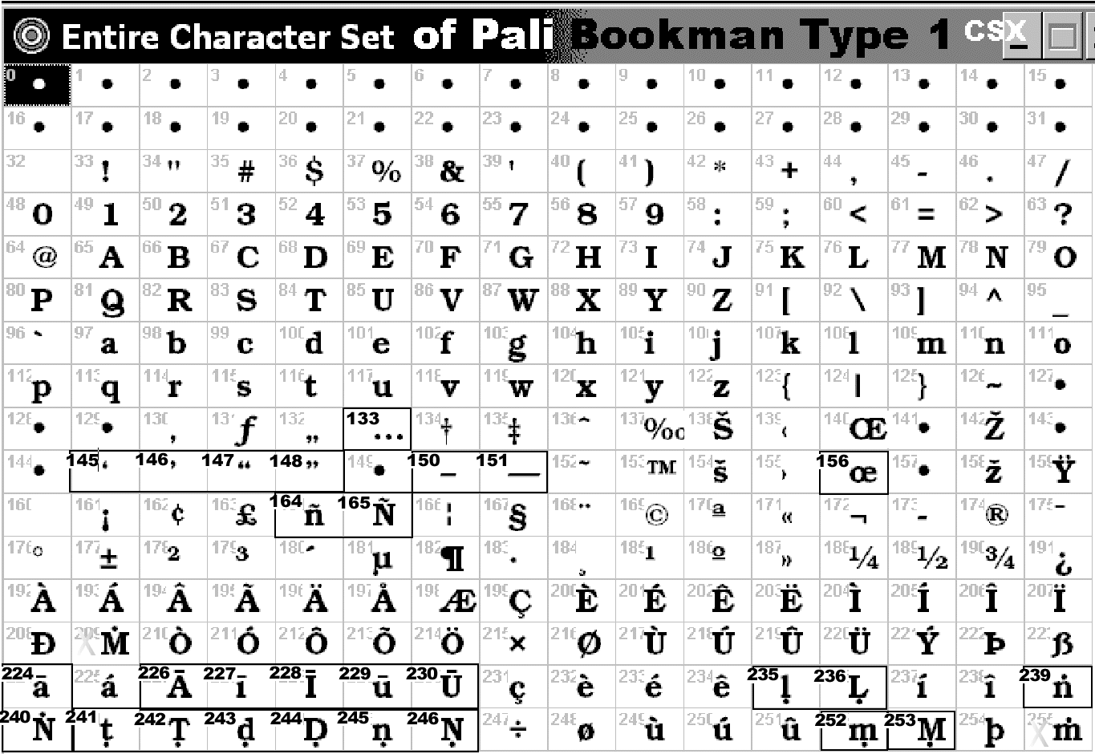
In the example (on right) of the Pali character set (highlighted) in the entire character set, the code numbers are in the top left corner of the square enclosing each character. For example ‘Capital long A’ â is number 226. Entering Alt+0226 (with numlock on) will enter that character into the text. Using this guide any character in any font (with the character set viewed by some means) can be used. A special case is the new Unicode standard using Unicode fonts. This is another method altogether and is not covered here. [In summary Unicode fonts are very large, not all DTP/wp applications have an easy method to enter the extended characters required. Generally OpenType fonts do not have the Pali characters required. Modified (smaller) Unicode fonts do not have Pali characters either.]

This character map graphic is repeated on following page, oriented so as to be larger on the page for use as a guide when entering Pali characters with the keyboard. The Pali characters with their matching extended character set numbers are indicated above. Other characters such as “ellipsis … ” may have to be entered manually.

If possible use only Type 1 fonts in a document to avoid problems when printing (if TrueType fonts are used also). If other characters are required, such as Sanskrit, there are compatible Type 1 fonts available such as “Times_Norman” which matches nicely with Pali Times. Times_Norman has such characters as a “long e” — at position Alt+0227 ã — which is also in the same character position as the “long i” ã in the Pali CSX convention. Times_Norman is an old font – indicating the difficulties which arise when standard character positions are not kept. However with care these fonts can be used together. There is no uppercase “long E” or uppercase “long O” however the lowercase “long o” ¯ is useful and both can substitute when enlarged as Capital letters if required for alternate Pali spellings.

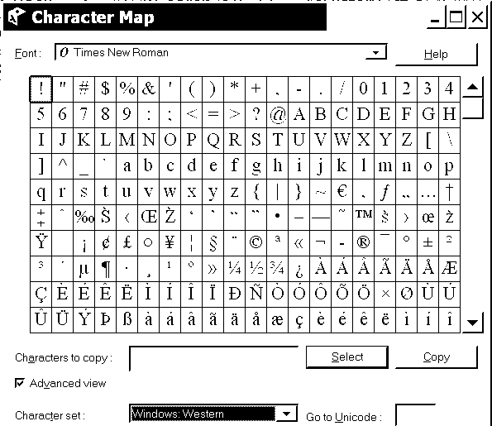
This is an example of the Windows 2000 character map applet, which is marginally better than the almost unusable charmap applet in previous version of Windows (see graphic on bottom of page 7). It is possible to select a character and transfer it to the clipboard and then paste this character or characters into the text. This method is suitable for occasional use only. Another method would be to have an example of all the Pali characters required at the front of the text file and then cut/copy and paste from there, but this is also inefficient. Using Word macros is the most efficient solution. There are keyboard utilities that might prove useful otherwise. On the last page (p.8) of this guide there is a standard Windows 256 ASCII character map of the set.
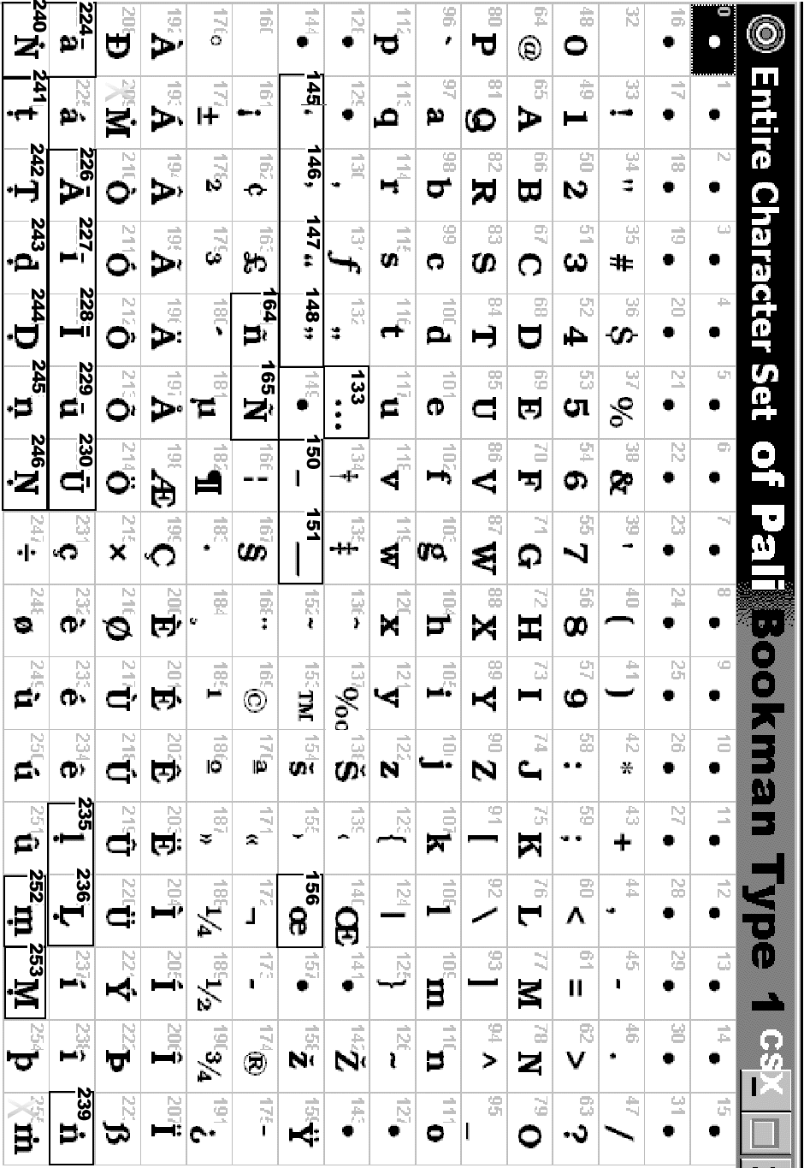
Use this character map for entering Type 1 Pali characters
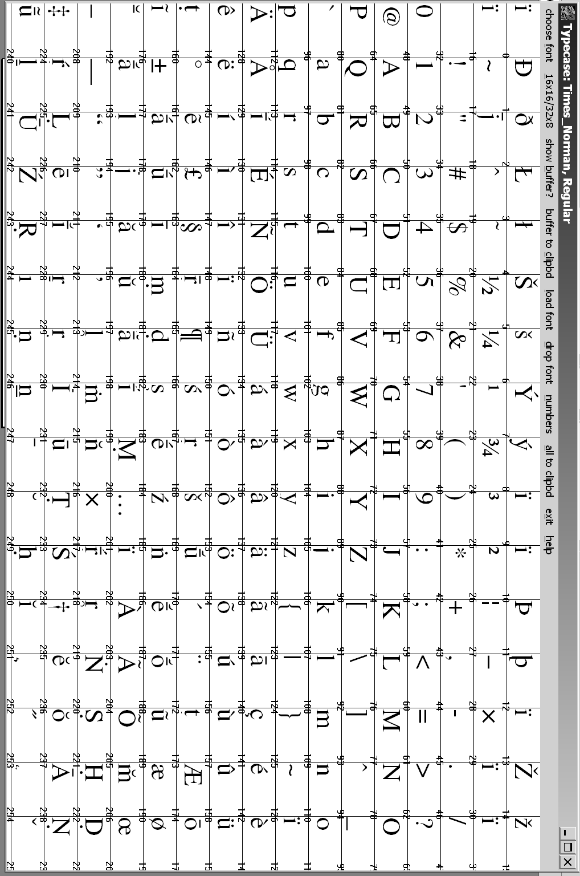
For Times_Norman the character numbers are in bottom right corner
An example of the Windows character set with the characters represented by hexadecimal numbers rather than ordinary numbers. In some character text viewers or applications this alternate view can be useful for entering characters. For example, in InDesign, through the insert character menu, Unicode or other character numbers can be entered as appropriate.
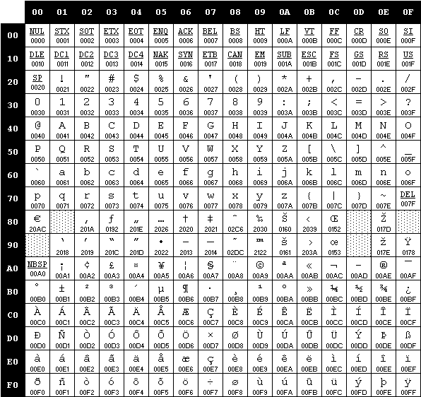
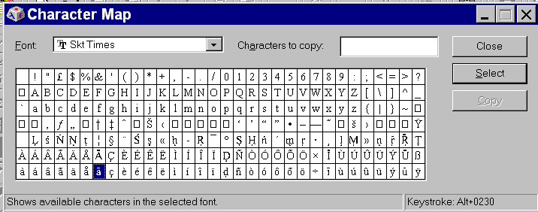Above is an example of the inadequate Windows 98 Character Map applet (CharMap)
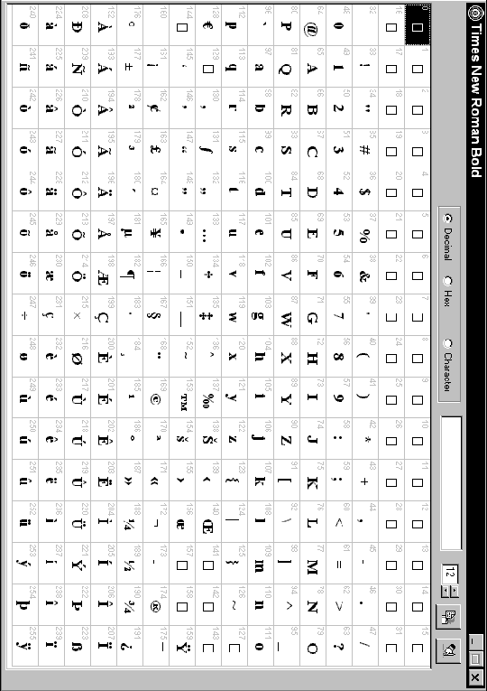
Above is the standard Windows character set representation which is useful as a reference.

